- Find the name and salary of those employees whose salary is greater than the average salary of all employees.
SELECT name, salary
FROM employees
WHERE salary > (SELECT AVG(salary) FROM employees);
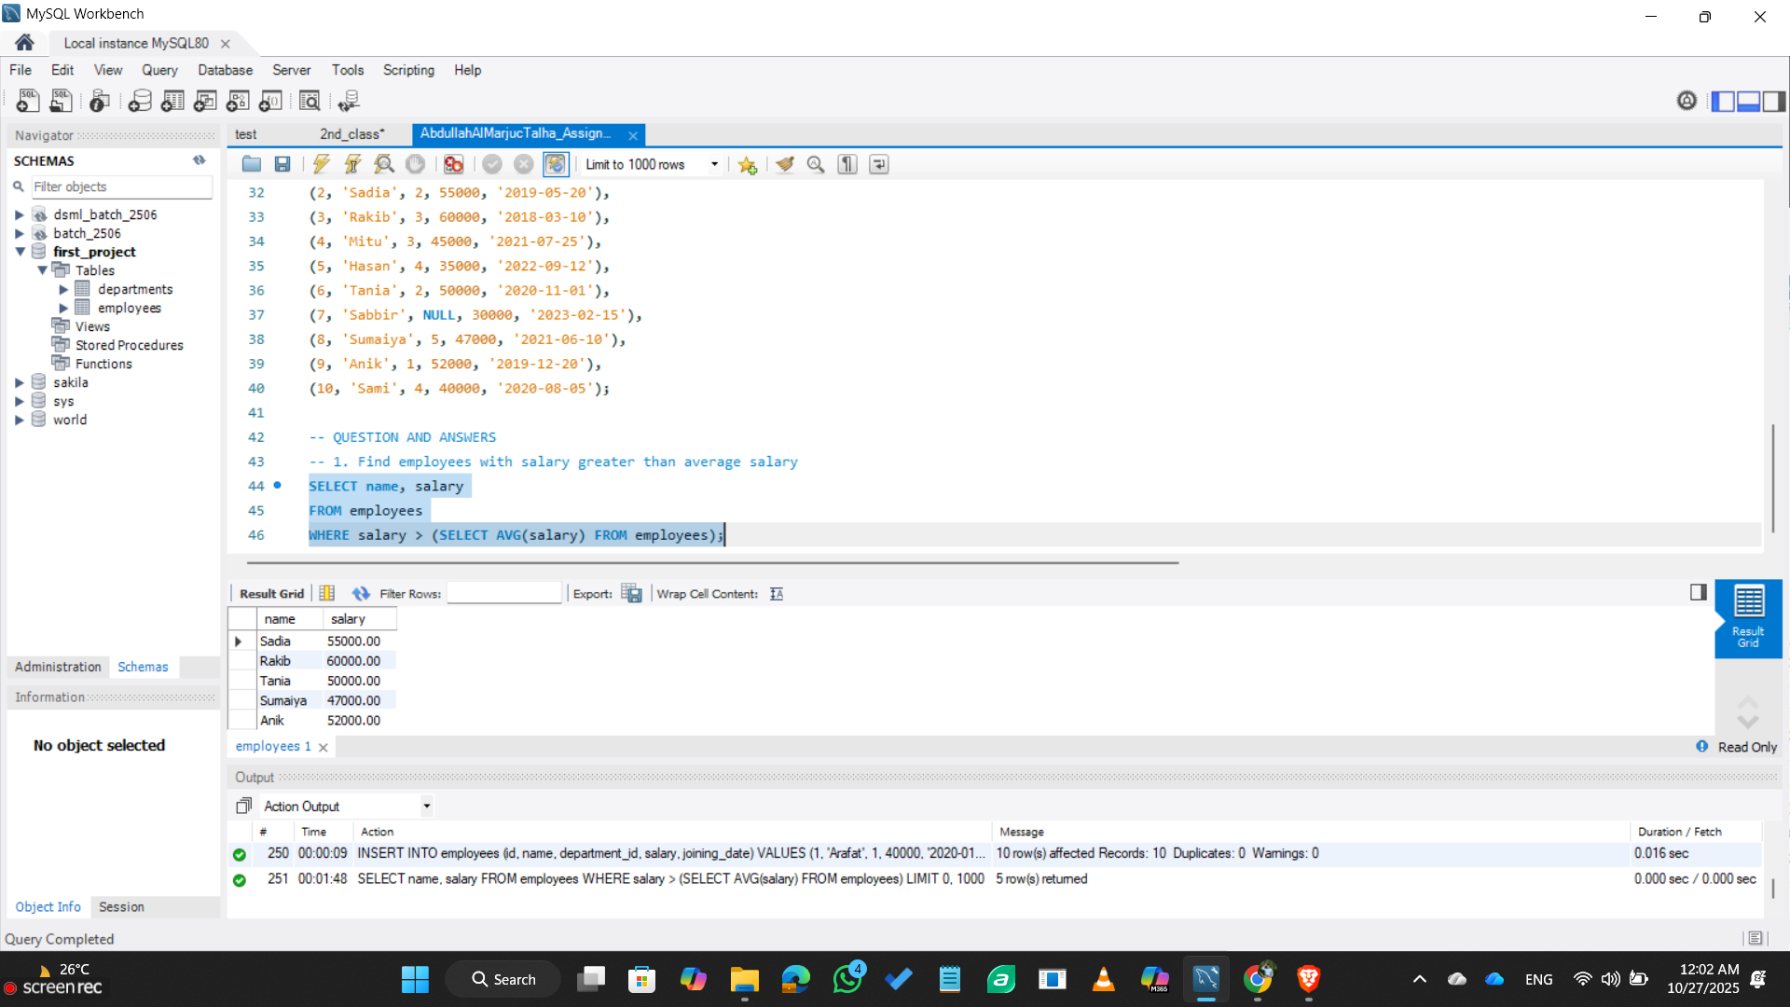

- Show the names of departments where at least one employee works.
SELECT DISTINCT d.name as department_name
FROM departments d
INNER JOIN employees e ON d.id = e.department_id;
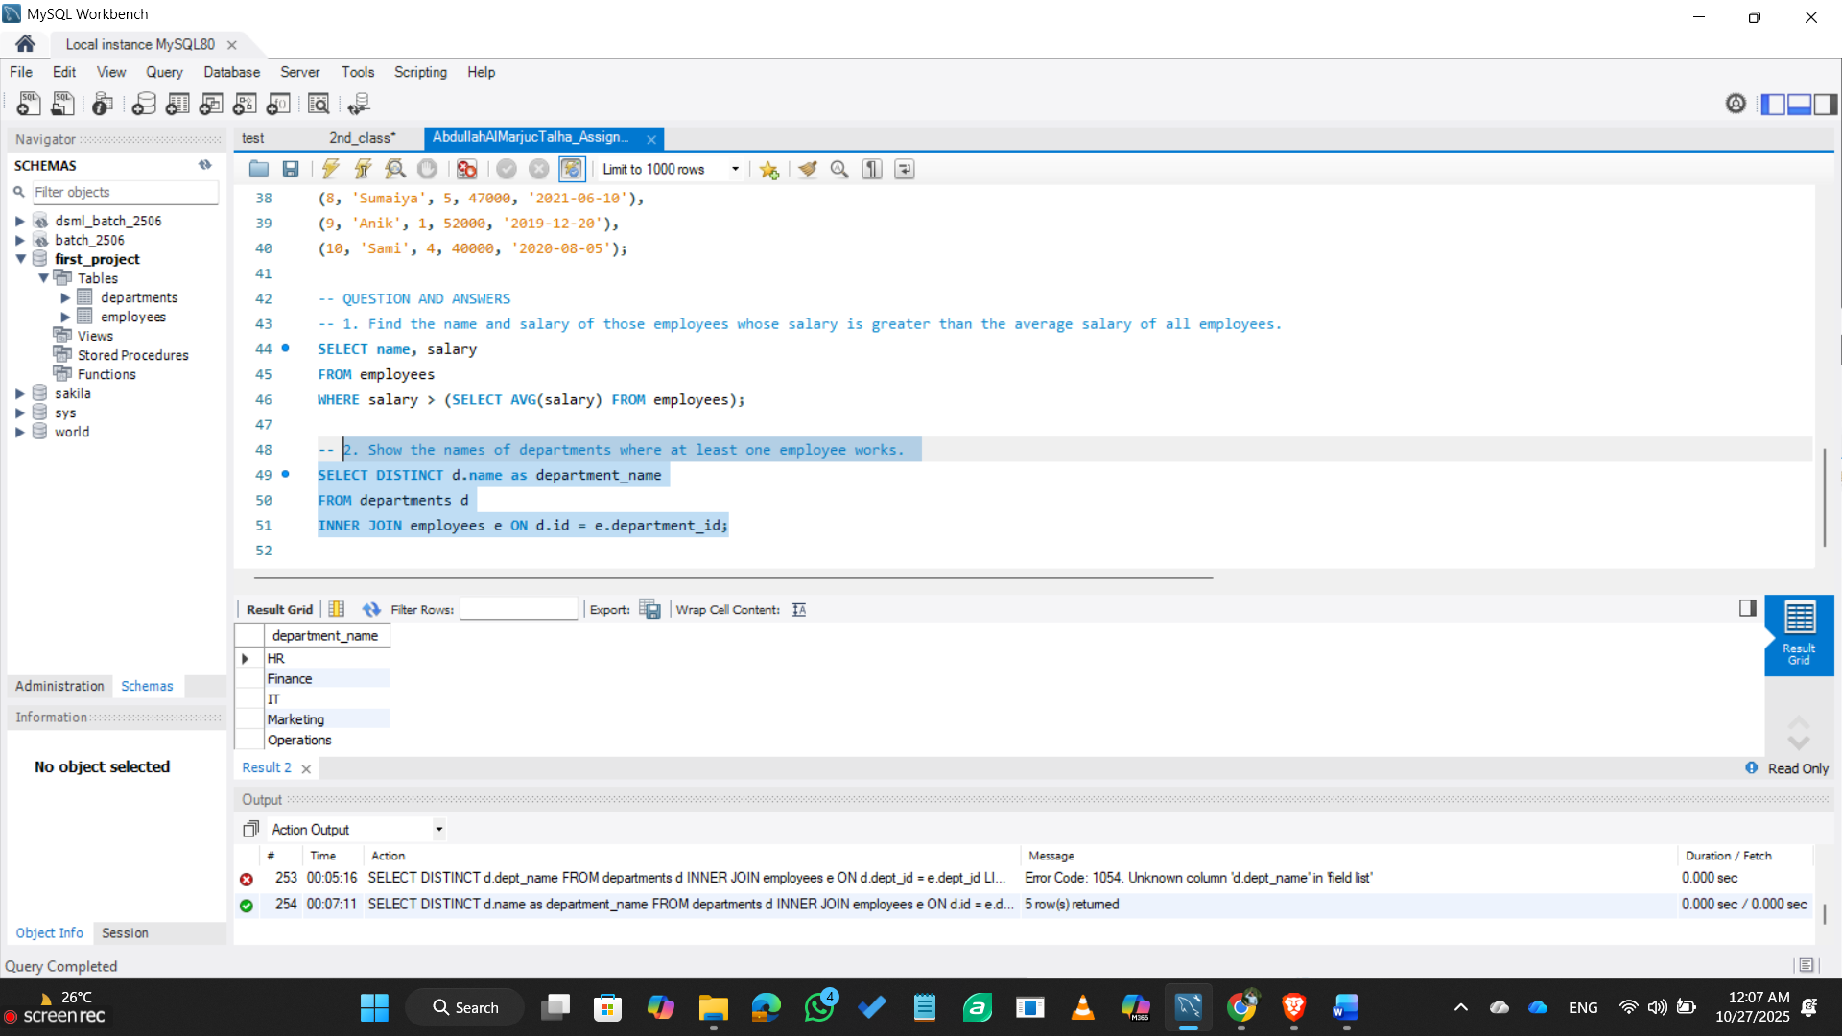

- ist all employees along with their department names (even if they don’t belong to any department).
SELECT e.name, COALESCE(d.name, 'No Department') as department_name
FROM employees e
LEFT JOIN departments d ON e.department_id = d.id;
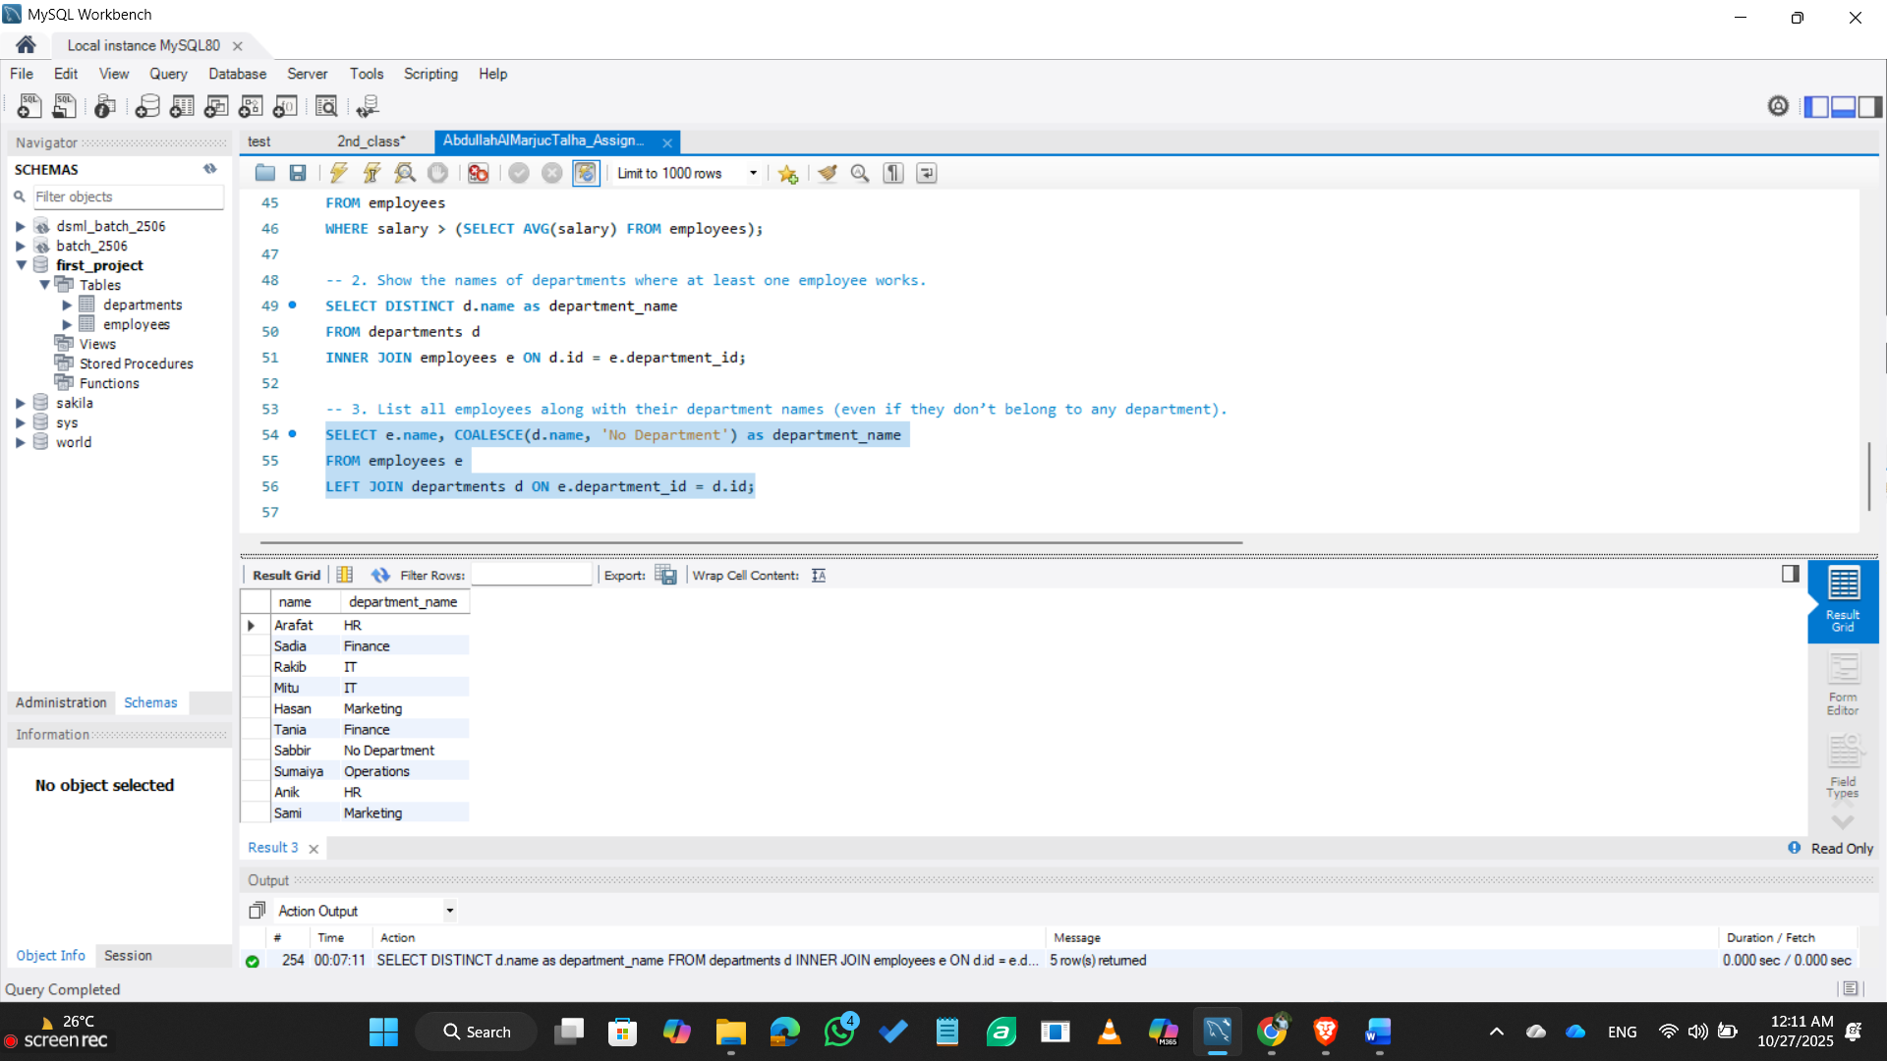

- Display project name and total number of employees working on each project.
SELECT d.name as department_name, COUNT(e.id) as total_employees
FROM departments d
LEFT JOIN employees e ON d.id = e.department_id
GROUP BY d.id, d.name;
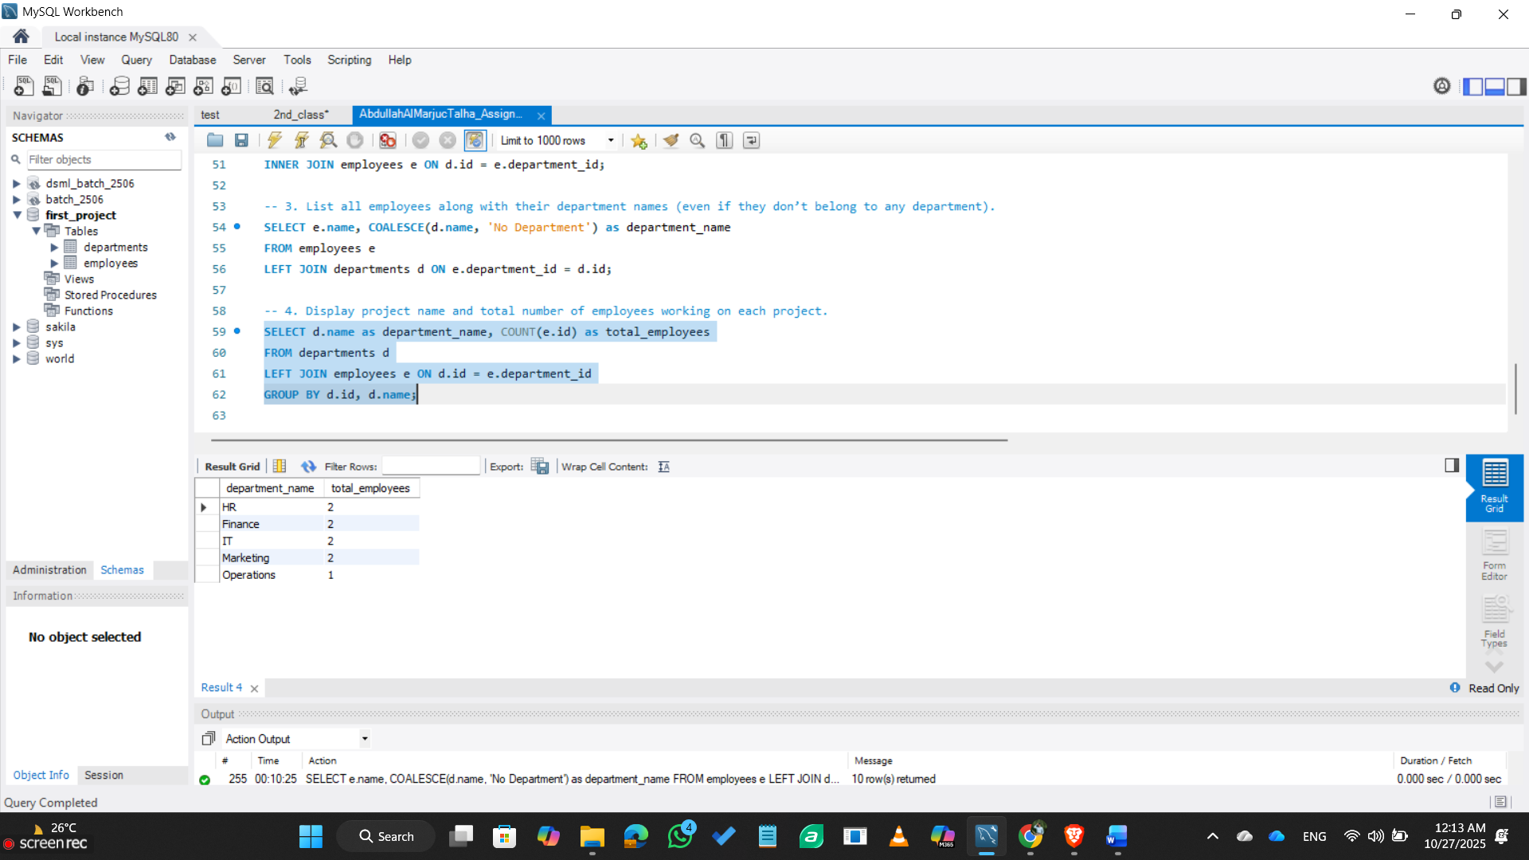

- Create a CTE to find the top 3 highest-paid employees.
WITH TopEmployees AS (
SELECT name, salary
FROM employees
ORDER BY salary DESC
LIMIT 3
)
SELECT * FROM TopEmployees;
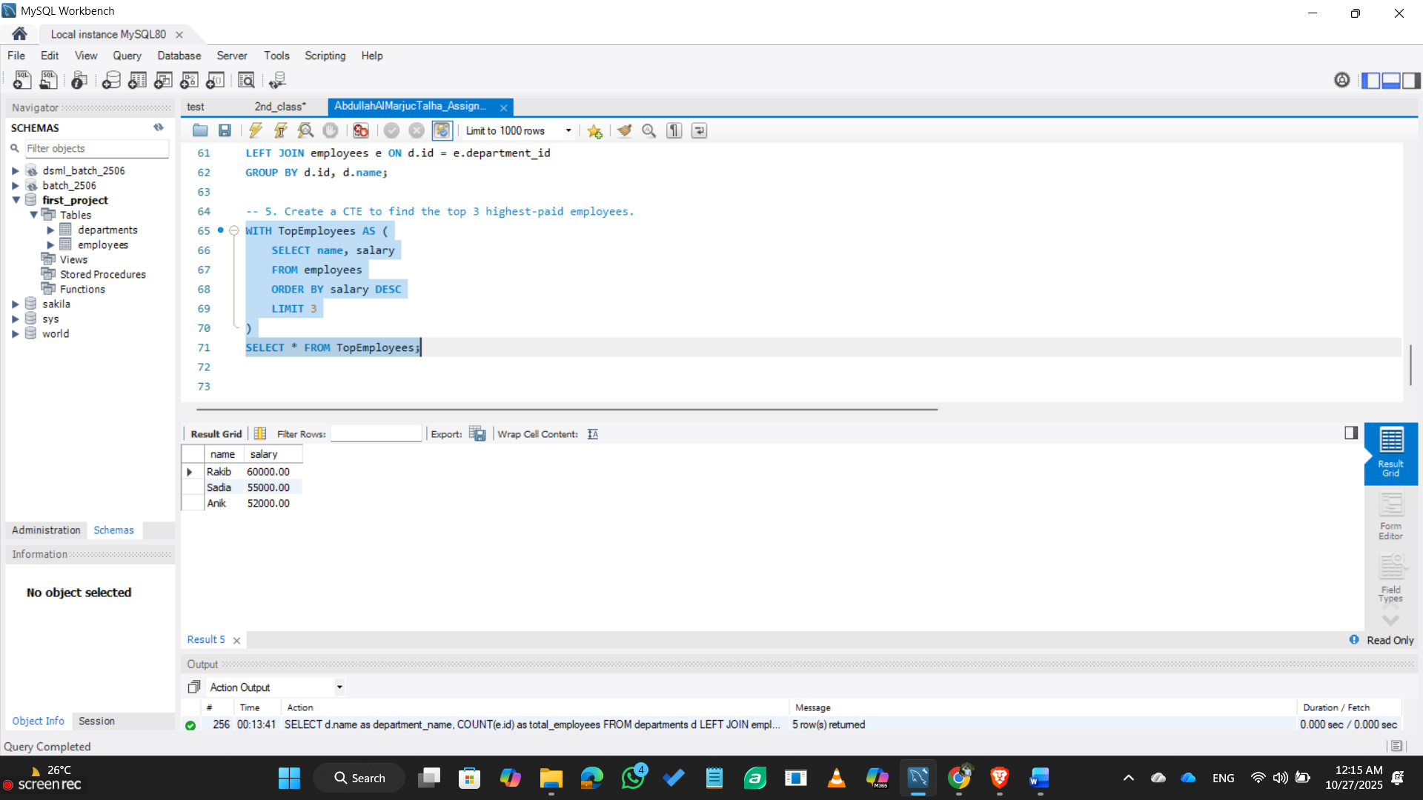

- Using a CTE, find each department’s average salary and select only those where avg salary > 50000.
WITH DeptAvgSalary AS (
SELECT d.name as department_name, AVG(e.salary) as avg_salary
FROM departments d
JOIN employees e ON d.id = e.department_id
GROUP BY d.id, d.name
)
SELECT * FROM DeptAvgSalary WHERE avg_salary > 50000;
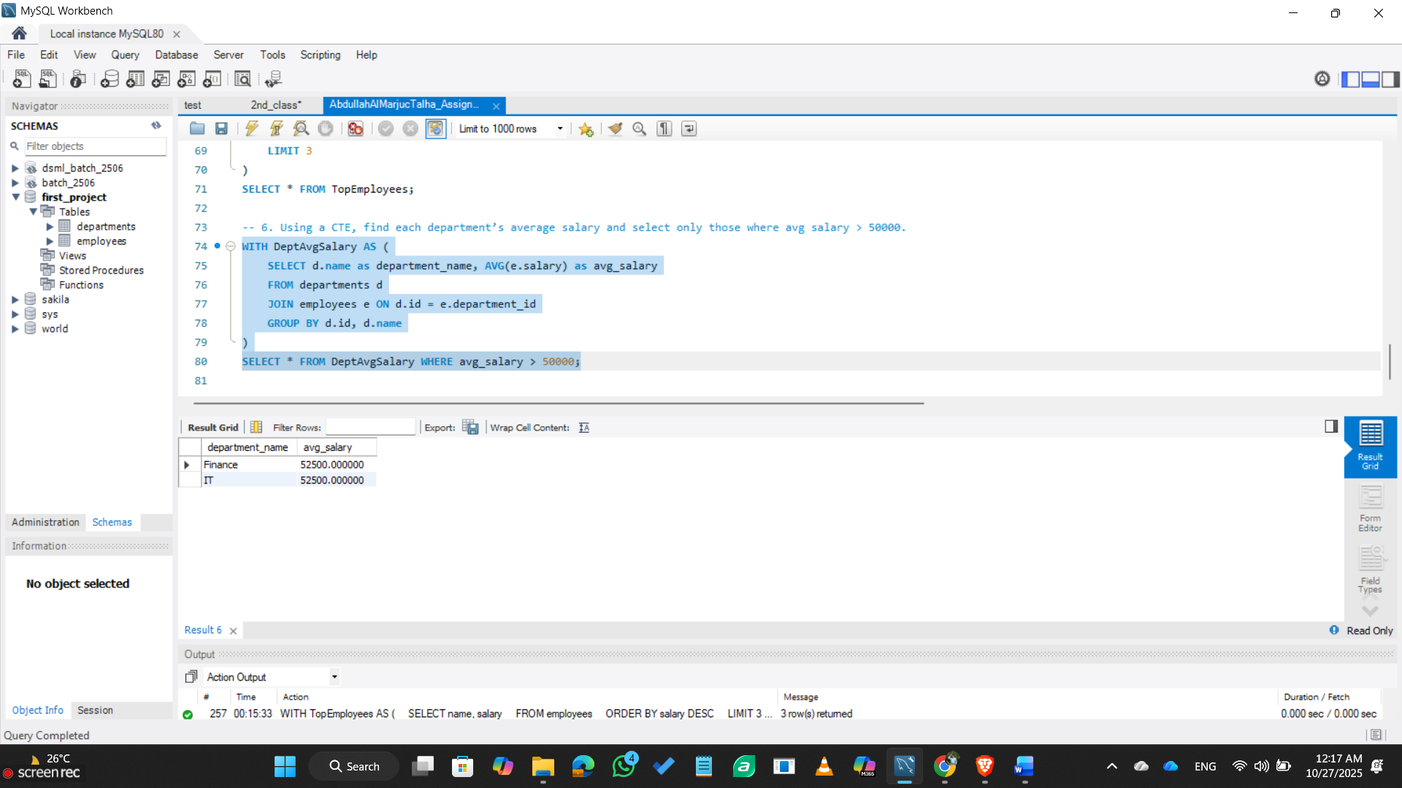

- Create a stored procedure to get all employees by department name (IN parameter).
DELIMITER //
CREATE PROCEDURE GetEmployeesByDepartment(IN dept_name_param VARCHAR(50))
BEGIN
SELECT e.name, e.salary, e.joining_date
FROM employees e
JOIN departments d ON e.department_id = d.id
WHERE d.name = dept_name_param;
END //
DELIMITER ;
CALL GetEmployeesByDepartment('IT');
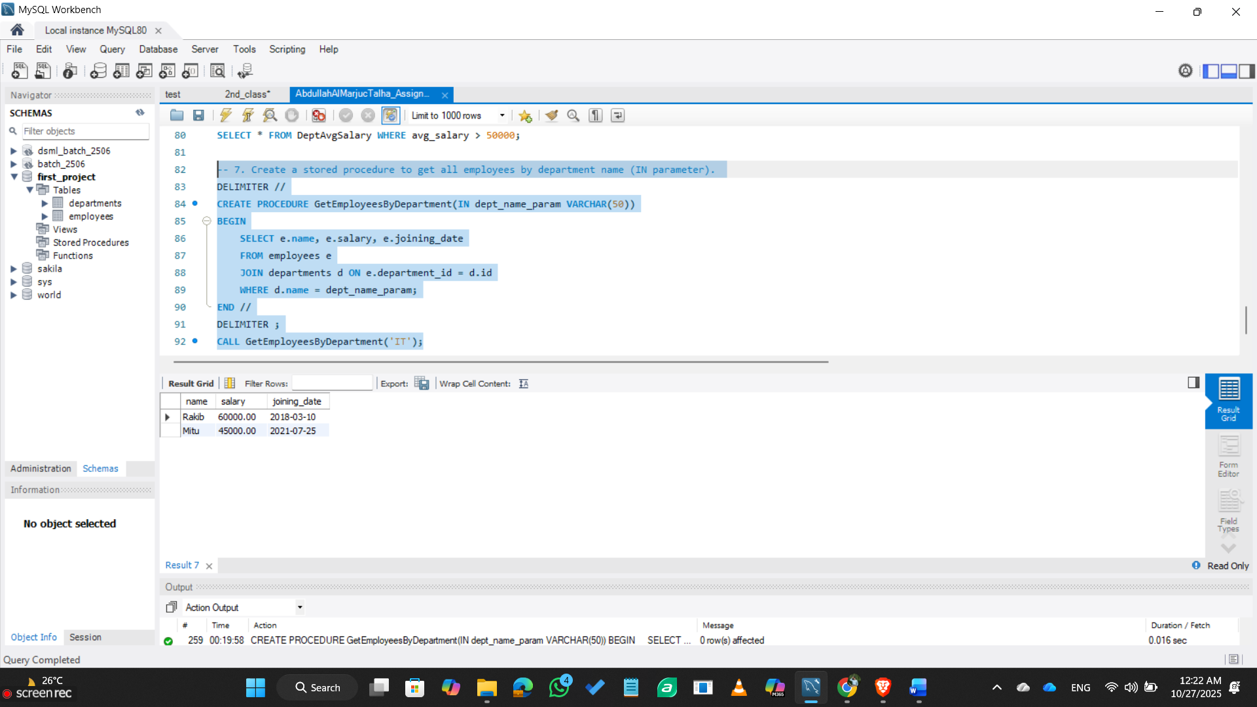

- Create a stored procedure that takes department name (IN) and returns employee count (OUT).
DELIMITER //
CREATE PROCEDURE GetEmployeeCountByDepartment(
IN dept_name_param VARCHAR(50),
OUT employee_count INT
)
BEGIN
SELECT COUNT(*) INTO employee_count
FROM employees e
JOIN departments d ON e.department_id = d.id
WHERE d.name = dept_name_param;
END //
DELIMITER ;
CALL GetEmployeeCountByDepartment('IT', @count);
SELECT @count as employee_count;
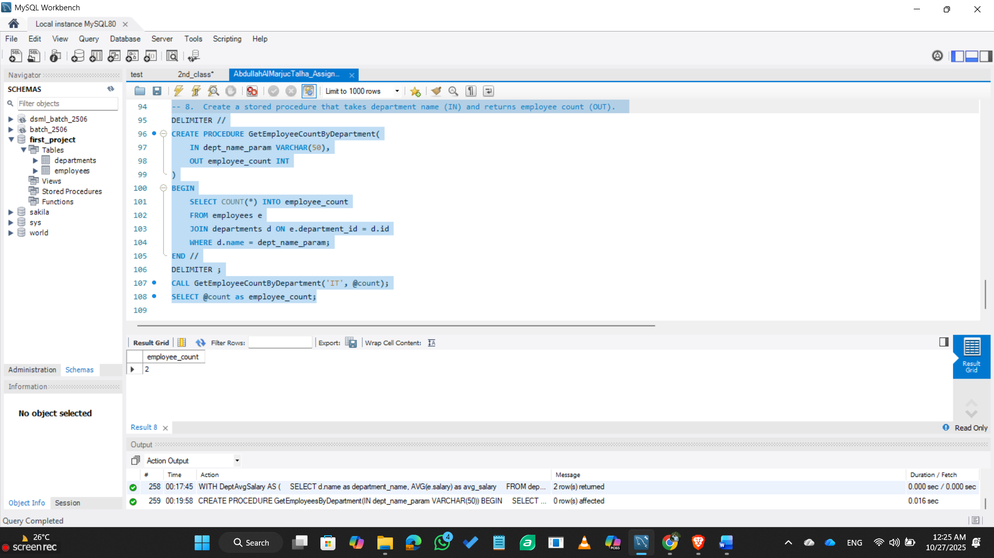

- Rank each employee based on their salary (highest to lowest).
SELECT
name,
salary,
RANK() OVER (ORDER BY salary DESC) as salary_rank
FROM employees;
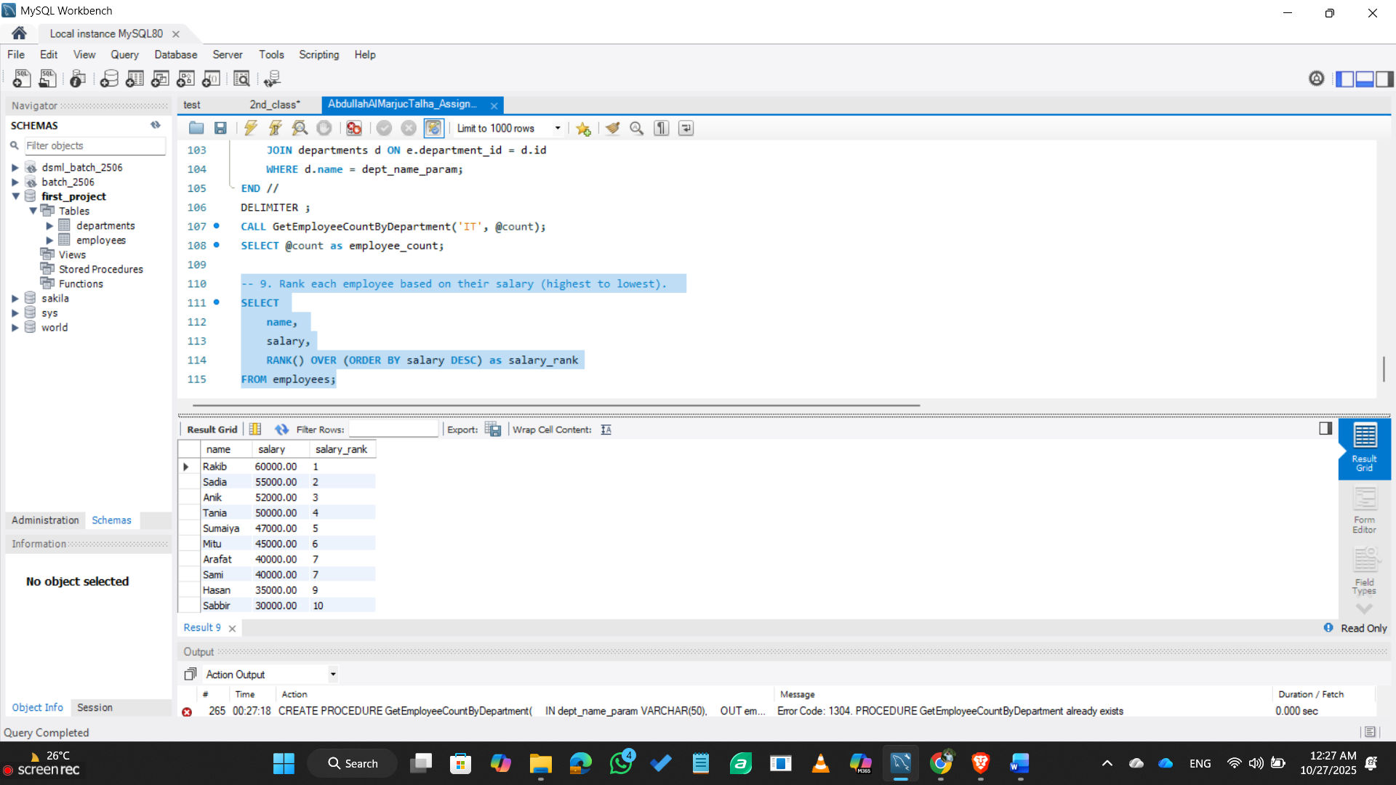
- Find employees who worked on more than one project.
SELECT e.name, d.name as department, d.location
FROM employees e
JOIN departments d ON e.department_id = d.id
WHERE d.location = 'Dhaka';
